Practical 30 :

Code :

import java.applet.Applet;

import java.awt.Color;

import java.awt.Graphics;

public class Back extends Applet{

public void paint(Graphics g) {

setBackground(Color.red);

}

}

Output :

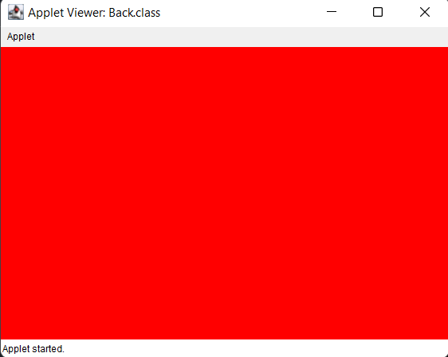

Code :

import java.applet.\*;

import java.awt.\*;

public class Cone extends Applet{

    public void paint(Graphics g){

    g.drawOval(200,80,200,50);

    g.drawLine(200,100,300,500);

    g.drawLine(400,100,300,500);

    }

}

Output :

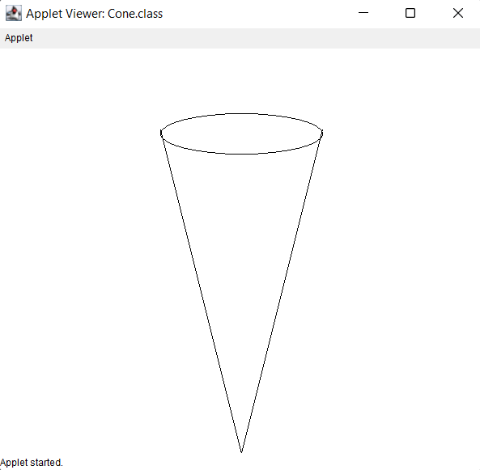

Code :

import java.applet.\*;

import java.awt.\*;

public class SqrCir extends Applet{

    public void paint(Graphics g){

        g.drawOval(150, 150, 100, 100);

        g.drawRect(100,100,200,200);

    }

}

Output :

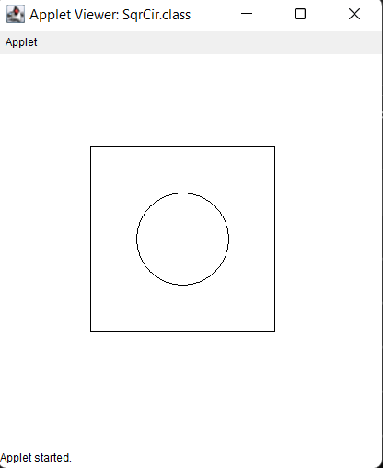

Code :

import java.applet.\*;

import java.awt.\*;

public class Cube extends Applet{

    public void paint(Graphics g){

        g.drawRect(500,400,100,100);

        g.drawRect(550,450,100,100);

        g.drawLine(500,400,550,450);

        g.drawLine(500,500,550,550);

        g.drawLine(600,400,650,450);

        g.drawLine(650,550,600,500);

    }

}

Output :

